Installation

**1. Backup your web directory and store database.**

Before installing the plugin, make sure to backup your files and database.

If you are going to use the native Magento backup function, navigate to **System -> Tools -> Backups** and perform ***System*** and ***Database*** backups

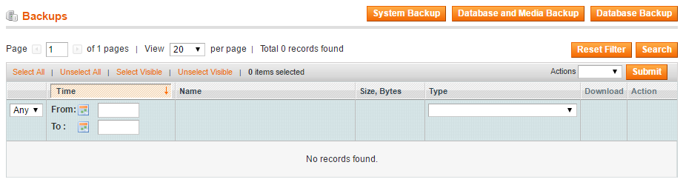

**2. Log in to the Magento backend**

**3. Disable compilation**

Navigate to **System -> Tools -> Compilation**.

If Compiler status is Disabled, you can skip to the next step

If Compiler is enabled, disable it.

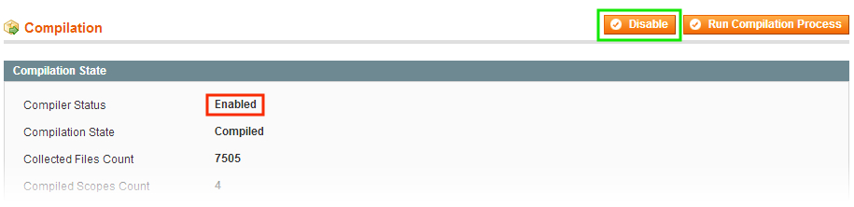

**IMPORTANT:** after the extension is installed, you can enable the compilation again; **IT IS CRUCIAL** that you use "**Run Compilation Process**" function, not just "Enable button"

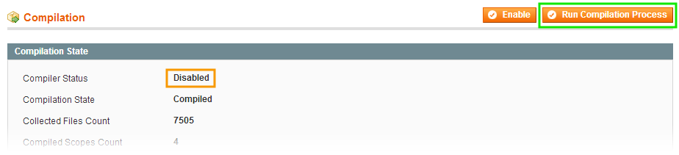Installing an extension with the Compilation enabled will result in store downtime.

**4. Flush store cache**

You can flush the store cache in 2 ways:

* **via the backend**:

Navigate to **System -> Cache Management** menu, and click **Flush Magento Cache** button

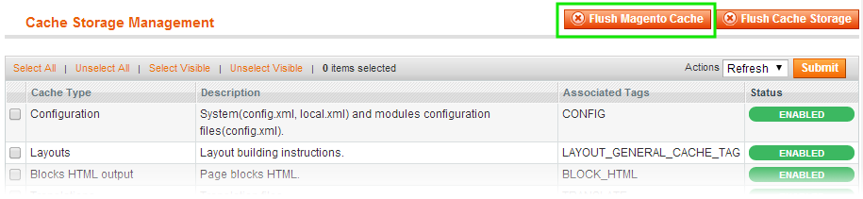

* **via filesystem**:

On your server, navigate to Magento root folder, then proceed to**/var/cache/;**delete all the content there.

**5. Copy the content of /step_1/ folder to your store's root directory**

If you are using a custom theme:

In case you are using a custom theme, it is recommended to copy the design files to your current theme's folders. In case there are several themes in use for the same store, the design files must be copied to each of them.

* Find this folder in the package: /step_1/app/design/frontend/base/default/ ; copy its content to /app/design/frontend/[your_package]/[your_theme]/
* Find this folder in the package: /step_1/skin/frontend/base/default/ ; copy its content to /skin/frontend/[your_package]/[your_theme]/

**7. Copy the content of /step_2/ folder to your store's root directory.**

**8. Flush store cache again; log out from the backend and log in again.**